# Table S1: Raw Materials & Details of the Synthetic Approach

|  |  |
| --- | --- |
| ***Name of Sheets*** | ***Data included*** |
| 1. 759 Apps | * App attributes |
| 2. Feature words for SA | * Adjectives, adverbs as sentiment feature words |
| 3. 2063 Comments & Sentiments | * Contents of all comments * Sentiments from 3 sources for each comment (Text blob, Google, and Experts) |
| 4. 362 Apps having comments for Correlation Analysis | * App attributes * App sentiment score |
| 5. Problems in 928 Negative Comments | * Contents of all negative comments * Problems complained in each negative comments (Experts) |

The specific contents can be seen in the ‘Table S1. Raw materials and Details of the approach***’*** or downloaded from https://github.com/0AnonymousSite0/A-Domain-Knowledge-Incorporated-Text-Mining-Approach-for-Capturing-User-Needs-on-BIM-Applications

# Table S2. Experts for incorporating domain knowledge

|  |  |  |  |  |
| --- | --- | --- | --- | --- |
| ***Sub-Steps*** | ***Name*** | ***Institutions*** | ***Domain*** | ***Experience*** |
| Label user comments | Mr Zhou | The University of Hong Kong | BIM | >5 years |
| Mr Wang | JieHong Engineering Consulting Co., Ltd. | BIM | >5 years |
| Mr Yang | The University of Hong Kong | BIM | >5 years |
| Dr Lee | The University of Hong Kong | BIM & Computer science (CS) | >15 years |
| Dr Xv | The University of Hong Kong | CS & Machine Learning | >20 years |
| Work respectively & Reach a consensus | Mr Zhou | The University of Hong Kong | BIM | >5 years |
| Mr Yang | The University of Hong Kong | BIM | >5 years |

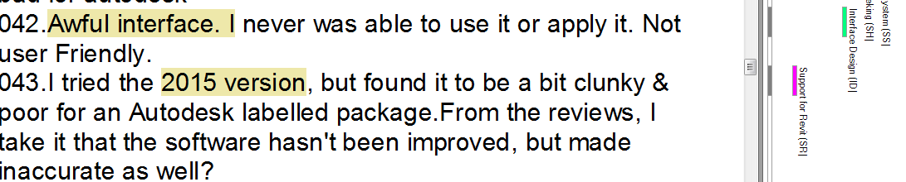

# Figure S1. Labels for user problems in NVivo (Screenshot)

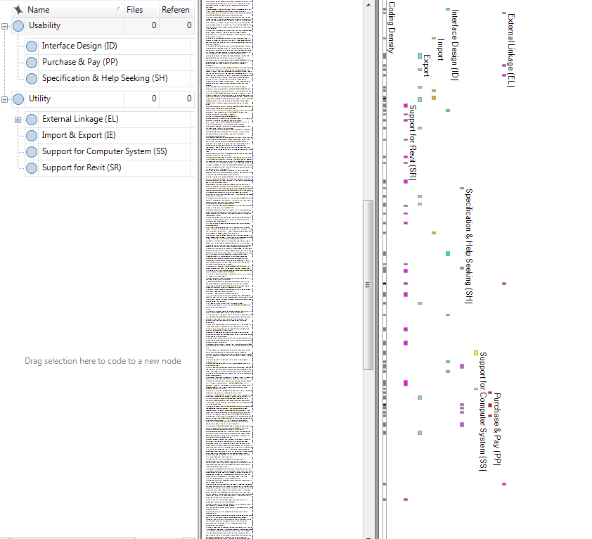

Labels

Comments

Types of problems

# Figure S2. Labels for user problems in NVivo (Screen shot)

# Table S3. Pseudocode for sentiment analysis

|  |  |
| --- | --- |
| Sentiment Analysis for user comments | |
| **Input:** *CommentArray, SentimentArray, SentimentFeatureWords* | |
| **Output:** *SAmodel, SAModelAccuracy* | |
| 1 | **Import** NumPy // Provide functions of Array calculation, RandomChoose**,** Remove. |
| 2 | **Import** TextBlob // Provide functions of Tokenize, RemoveStopwords. |
| 3 | **Import** Google Natural Language **//** Provide functions ofIdentifyLanguage, TranslateLanguage. |
| 4 | *TrainingSetComment*, *TrainingSetSentiment*, *TestingSetComemnt*, *TrainingSetSentiment* ← **RandomChoose** (*CommentArray*, *SentimentArray*) |
| 5 | **Function** **TextProcessing** (*Array*) |
| 6 | **For** *Comment* **in** *Array* **Do** |
| 8 | **if** *English=* **IdentifyLanguage** *Comment* **then** |
| 9 | *Comment* ← **TranslateLanguage** (*Comment*) |
| 10 | **End if** |
| 11 | *WordArray* ← **Tokenize (***Comment*) |
| 12 | *WordArray* ← **RemoveStopwords** (*WordArray*) |
| 13 | *WordArray* ← **ExtractSentimentFeatureWords** (*WordArray*) |
| 14 | *Comment* ← *WordArray* |
| 15 | **End for** |
| 16 | **Return** *Array* |
| 17 | **End Function** |
| 18 | **Function** **ExtractSentimentFeatureWords** (*Array*) |
| 19 | **For** *Word* **in** *Array* **Do** |
| 20 | **if** *Word* **not in** *SentimentFeatureWords then* |
| 21 | *Array* ←**Remove** (*Array, Word*) |
| 22 | **End if** |
| 23 | **End for** |
| 24 | **Return** *Array* |
| 25 | **End Function** |
| 26 | *TrainingSet* ← **TextProcessing** (*TrainingSetComment*) |
| 27 | *TestingSet* ← **TextProcessing** (*TestingSetComment*) |
| 28 | *SAModel* ← **TraniningClassifier** (*Training Set, TrainingSetSentiment*) |
| 29 | *SAModelAccuracy* ← **SAModel** (*Testing Set, TrainingSetSentiment*) |

# Table S4. Pseudocode for sentiment analysis

|  |  |
| --- | --- |
| Topic model for identifying user problems | |
| **Input:** *CommentArray, TopicArray, ProblemFeatureWords* | |
| **Output:** *TopicModel, TopicModelAccuracy* | |
| 1 | **Import** NumPy // Provide functions of Array, RandomChoose**,** Remove. |
| 2 | **Import** TextBlob // Provide functions of Tokenize, RemoveStopwords. |
| 3 | **Import** Google Natural Language **//** Provide functions ofIdentifyLanguage, TranslateLanguage. |
| 4 | **Import** Stanford Topic Modelling Toolbox // Provided SLDA algorithm |
| 5 | *TrainingSetComment*, *TrainingSetSentiment*, *TestingSetComemnt*, *TrainingSetSentiment* ← **RandomChoose** (*CommentArray*, *TopicArray*) |
| 6 | **Function** **TextProcessing** (*Array*) |
| 8 | **For** *Comment* **in** *Array* **Do** |
| 9 | **if** *English=* **IdentifyLanguage** *Comment* **then** |
| 10 | *Comment* ← **TranslateLanguage** (*Comment*) |
| 11 | **End if** |
| 12 | *WordArray* ← **Tokenize (***Comment*) |
| 14 | *WordArray* ← **RemoveStopwords** (*WordArray*) |
| 15 | *Comment* ← *WordArray* |
| 16 | **End for** |
| 17 | **Return** *Array* |
| 18 | **End Function** |
| 19 | *TrainingSet* ← **TextProcessing** (*TrainingSetComment*) |
| 20 | *TestingSet* ← **TextProcessing** (*TestingSetComment*) |
| 21 | *TopicModel* ← **TraniningClassifier** (*Training Set, TrainingSetSentiment*) |
| 22 | *TopicModelAccuracy* ← **TopicModel** (*Testing Set, TrainingSetSentiment*) |